**Guide for the installation of Node.js (JavaScript Runtime Environment), Angular CLI (Command Line tool for Angular Apps) and Visual Studio Code (Source Code Editor).**

**Note-** This guide is for Windows. For macOS users, perform the equivalent steps.

**Node.js Installation.**

**Note–** Node.js is a platform that allows us to execute JavaScript code outside of the web browser. Npm is automatically installed with Node.js. Npm is a package manager for the JavaScript programming language.

1. Go over to the Node.js website using the following URL:

<https://nodejs.org/en/download/>

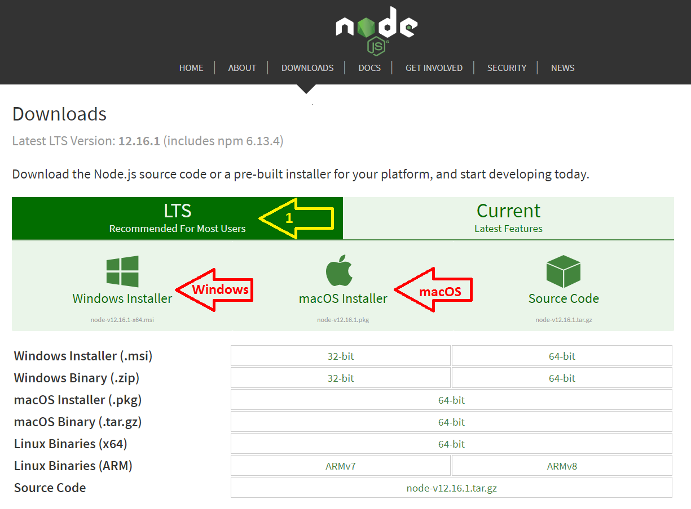You will get the following web page. First, select the LTS option (for long-term service versions), then pick the appropriate installer for your system.

1. Install Node.js on your computer.
2. Execute the installer downloaded in the previous step. Again, accept the default settings unless you need something specific for your system.

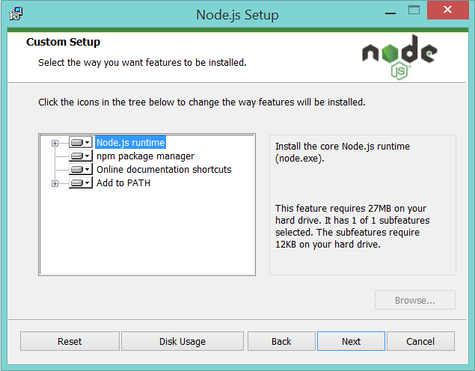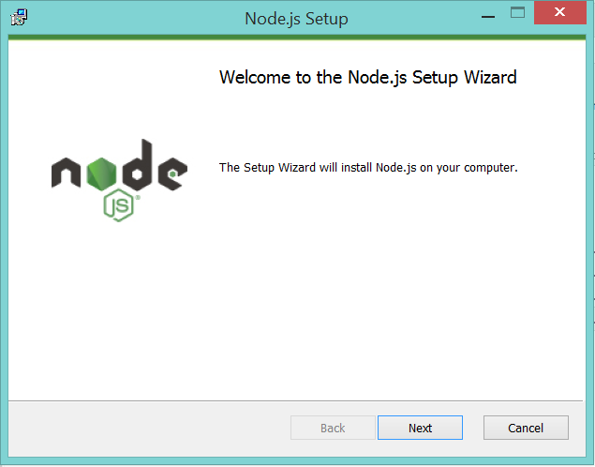

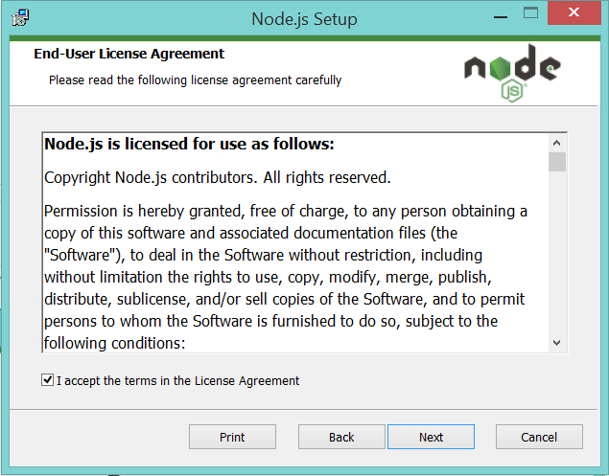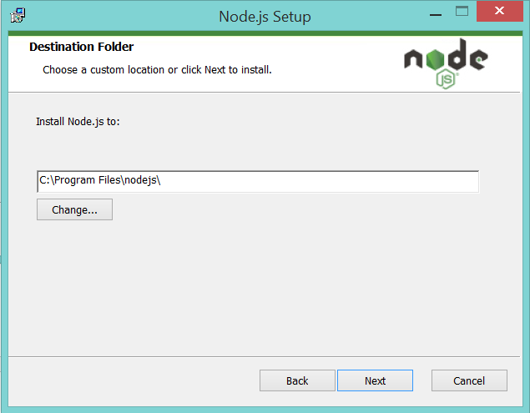

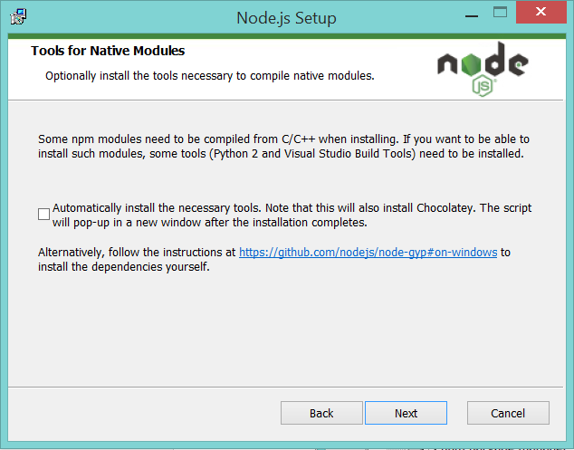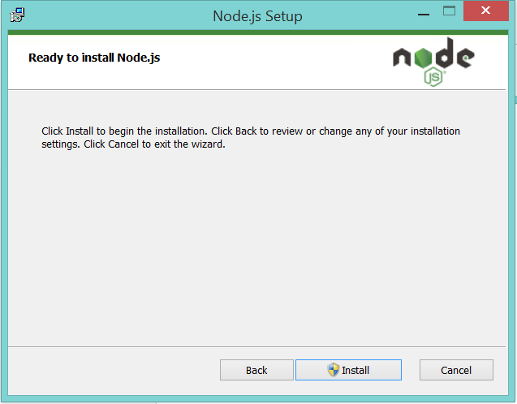

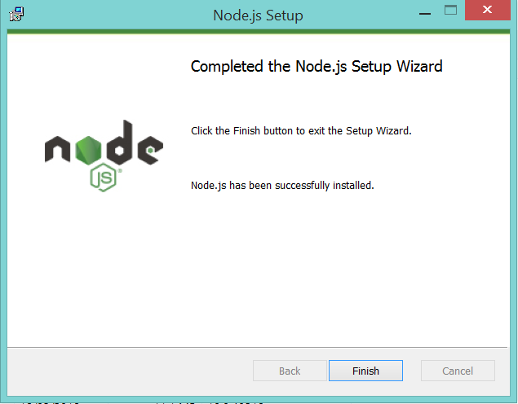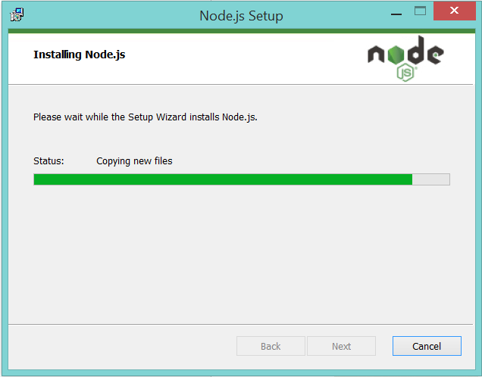

1. Open a new Windows command line or macOS terminal to verify the Node.js and NPM installation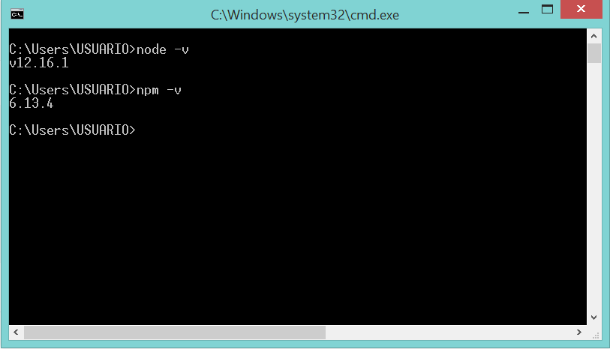.

**Angular CLI Installation.**

**Note-** Angular CLI is a command-line interface tool used to initialize, develop, scaffold, and maintain Angular applications.

1. Open a new Windows command line or macOS terminal to install Angular CLI.

And run *On Windows:* ***npm install -g @angular/cli***

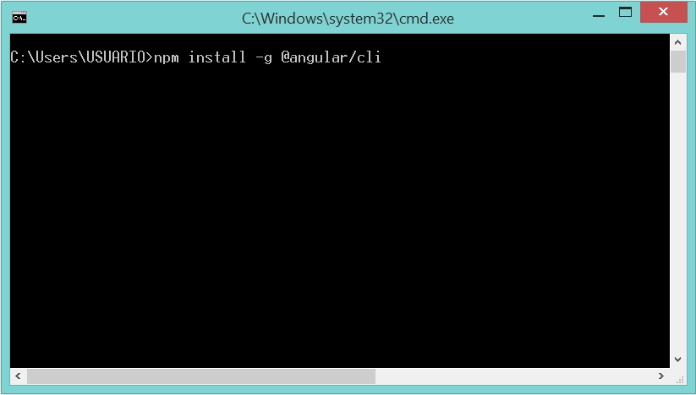 *On macOS:* ***sudo******npm install -g @angular/cli***

1. Once the installation is completed, you will see the following window.

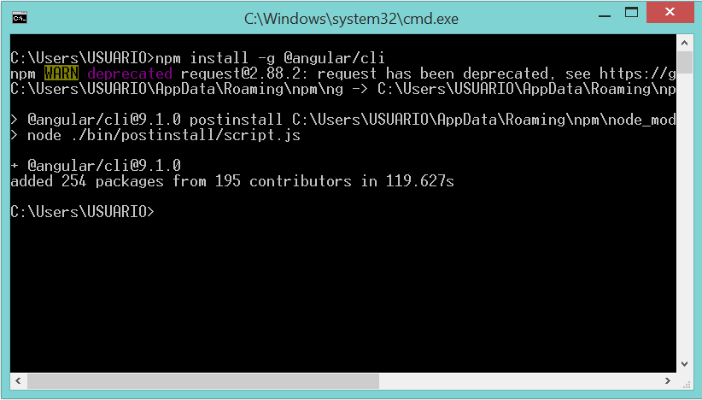

1. Run the command below to verify the Angular CLI installation.

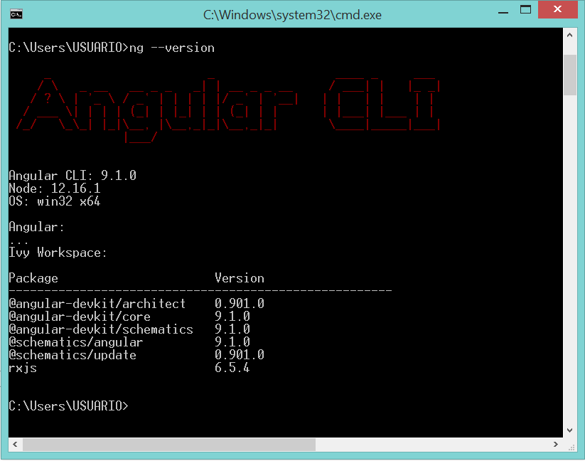Run: ***ng version***

**Visual Studio Code (VSC) Installation.**

**Note-** VSC is a source-code editor developed by Microsoft for Windows, Linux and macOS.

1. Go over to the Visual Studio Code website using the following URL:

<https://code.visualstudio.com/Download>

You will get the following web page. Pick the right installer for your system. For Windows choose the *64-bits* **System Installer**. 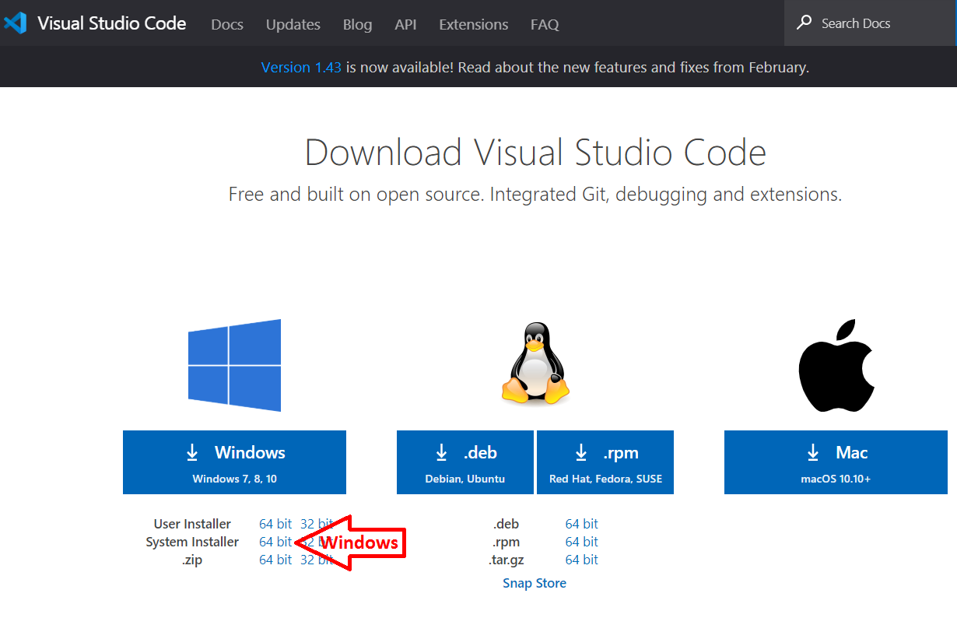

1. Install Visual Studio Code on your computer.
2. Execute the installer downloaded in the previous step. Again, accept the default settings unless you need something specific for your system.

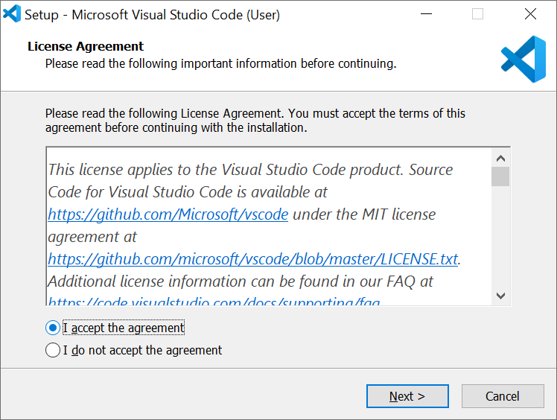

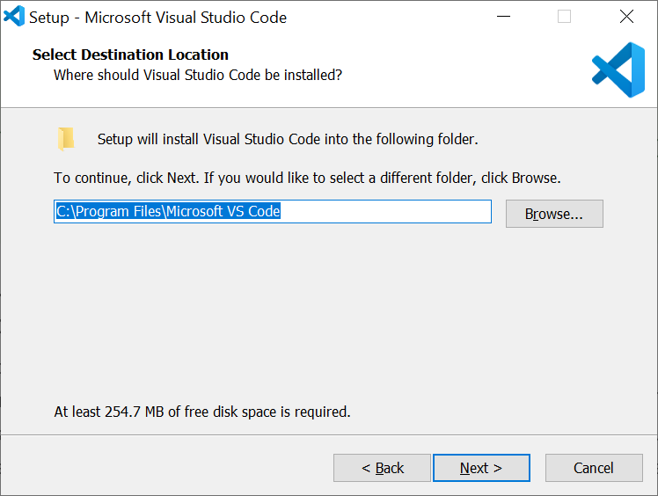

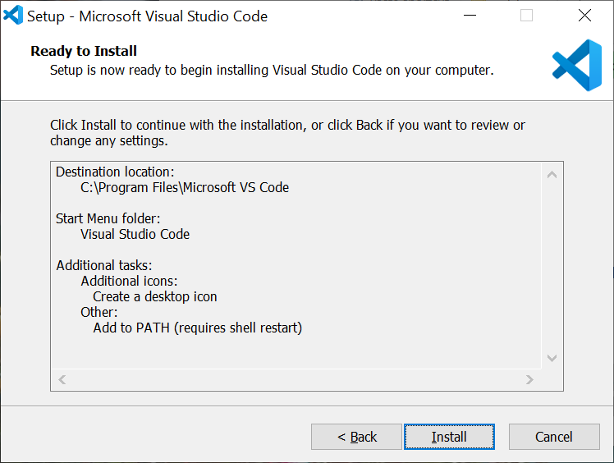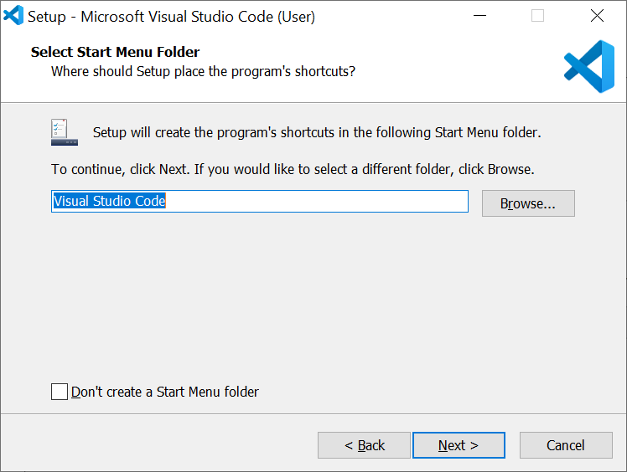

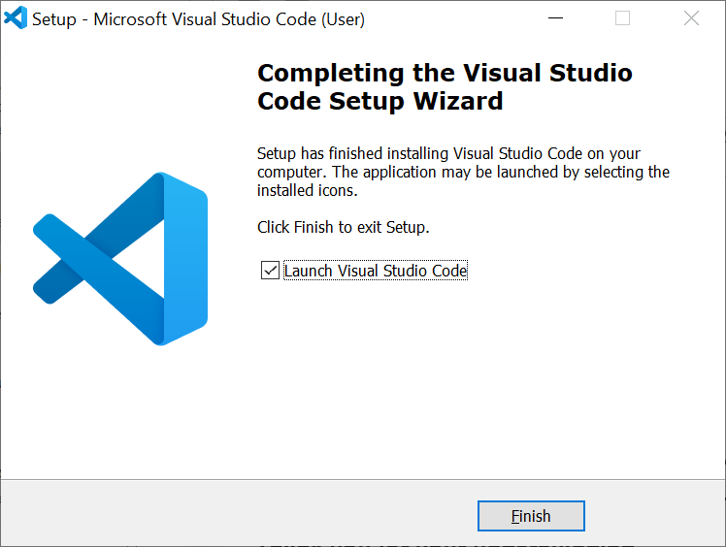

1. **Set the default VSC terminal to the Windows Command Prompt (for Windows 10 users only)** - Visual Studio Code (VSC) uses “PowerShell” by default as the terminal on Windows 10. Also, PowerShell is the command-line tool by default to Windows 10, and it will be the new standard in future Windows versions, 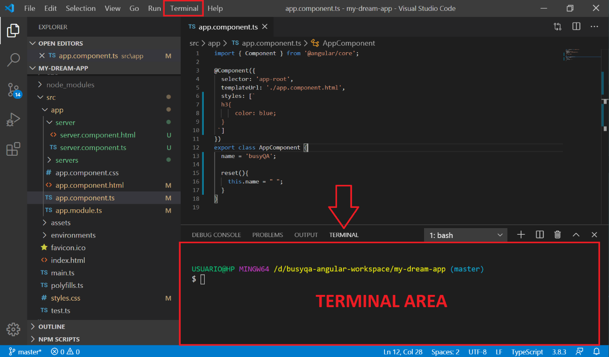as pointed out by Microsoft.

**Important-** Since we installed Angular CLI on the Windows command prompt, it won’t work if we try to run Angular CLI from PowerShell. Please follow the steps below to swap your VSC terminal to the traditional Windows command-line tool.

1. Open Visual Studio Code (VSC).
2. Press Ctrl + Shift + P to show all commands.
3. Type “*Terminal: Select Default Profile”* in the popup text box to filter the list.
4. Select the “*Terminal: Select Default Profile.” item from the list.*
5. You will be prompted to select your preferred terminal shell.
6. Select *“Command Prompt (cmd.exe).”*
7. Restart your Visual Studio Code, then open a new terminal window.

// End